Project Executable Files

Date | 13 july 2026
Team ID | SWTID-2026-2203
Project Name | Smart lender
Maximum Marks | 3 Marks

Project Executable Files
This section requires submission of all executable and deployable files for your project. Ensure all files are properly organized, named, and uploaded to the specified submission platform. The evaluator must be able to run or deploy your solution using the provided files and instructions.

Step 1: Submission Checklist

S.No | Item to Submit |  | Submitted  No / NA) | (Yes | /
1 | Complete source code (all files and folders) |  | yes
2 | README / Setup Guide (instructions to run the project) |  | yes
3 | requirements.txt / package.json / dependency file |  | yes
4 | Database schema / seed files (if applicable) |  | Yes(if using sql/no sql)
5 | Environment configuration file (.env.example similar) | or | yes
6 | Deployed application URL (if hosted) |  | Yes/NA
7 | APK / Executable binary (if applicable for mobile/desktop apps) |  | NA(usually web-based)
8 | Dockerfile / Containerization config (if applicable) |  | yes
9 | Test files and test results |  | yes
10 | Demo video or walkthrough (if required) |  | yes

Step 2: File / Folder Structure
Provide an overview of your project's file and folder structure below:

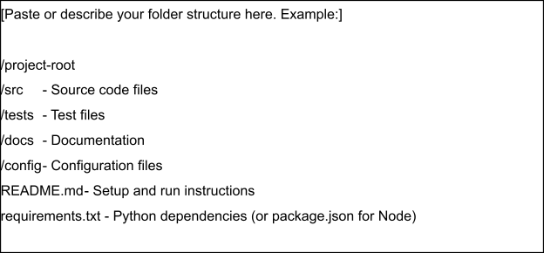

Step 3: Deployment / Access Details

Field | Details
Hosted / Deployed URL
Login Credentials  (Demo) | [Provide demo username and password for evaluator access]
Platform / Hosting  Provider | [e.g., Render, Vercel, AWS, Heroku, Azure]
Repository Link | [Link to your GitHub repository]
Demo Video Link | [Link to your YouTube or Loom demo]

Step 4: Run Instructions
Provide clear, step-by-step instructions for the evaluator to run your project locally:

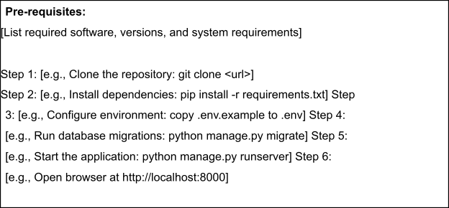

Step 5: Known Issues / Limitations

S.No | Known Issue / Limitation | Workaround / Status
1 | Data Imbalance: The training dataset often has many more approved loans than rejected ones, causing model bias. | Implemented: Used data augmentation techniques like SMOTE (Synthetic Minority Over-sampling Technique) to balance the classes.
2 | Limited Comparison: Focus on a single algorithm (e.g., Logistic Regression) can miss better performance from others. | In Progress: Comparing multiple models (Random Forest, Decision Trees, KNN) to identify the highest accuracy.
3 | Outdated/Incomplete Data: Reliance on static datasets might fail to capture real-time economic shifts or missing applicant details. | Planned: Integrating real-time data cleaning and log transformation to handle outliers and skewness in loan amounts.

